THE BEST RESUME TEMPLATE

How long do you think the average person spends reading a resume?
A. 6 Seconds
B. 23 Seconds
C. 1 Minute
D. 3 Minutes

Answer? A. Six Seconds! Yet, your resume is the most important tool for getting you through-the-metaphorical-door for an interview, along with how you apply for the job. You can find more about this in the book,
Art of the Job Search.

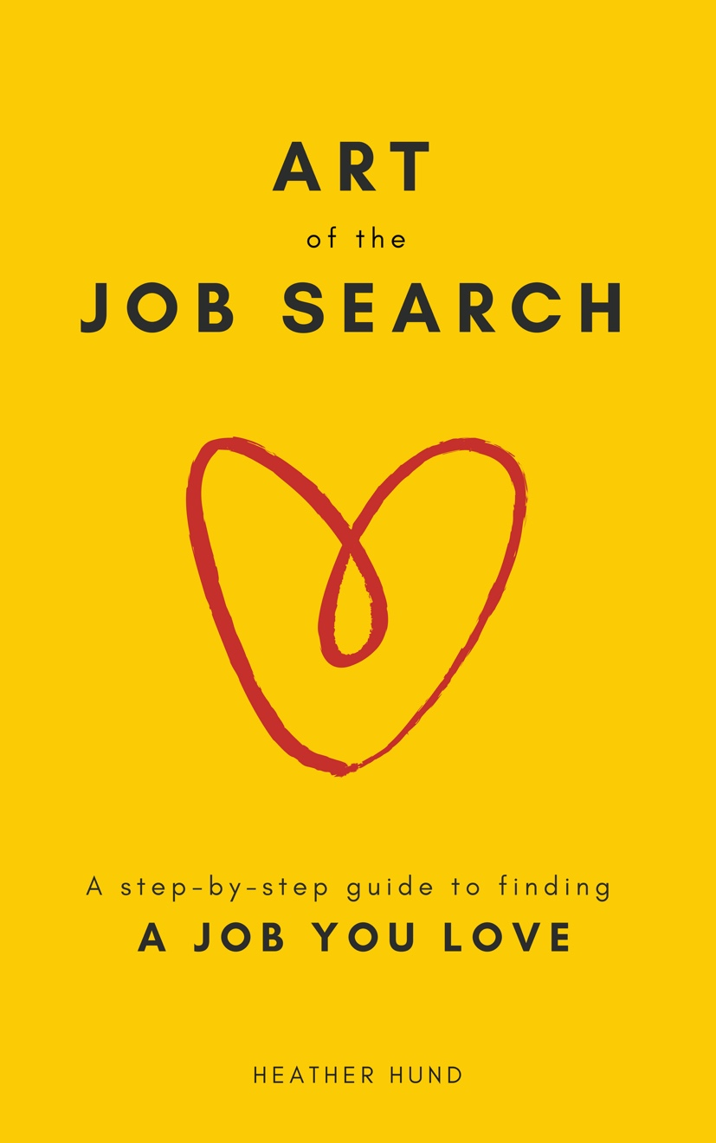

FIRST M. LAST
Address or City • Cell Phone • Email • LinkedIn Profile
Summary
Professional with [DEGREE] and [INDUSTRY/ FUNCTIONAL] experience; strengths include:
- Strength 1 – This is the most important part of your resume – for what to include here, check out the book and courses on Art of the Job Search
- Strength 2
- Strength 3
Professional Experience
Company City, State
Position & Title Dates employed [20XX – 20XX]
- Bullet 1 – For how to write incredible bullets, check out the book and courses on Art of the Job Search
- Bullet 2
- Bullet 3
- Bullet 4
Company City, State
Group – Job Title Dates employed [20XX – 20XX]
- Bullet 1
- Bullet 2
- Bullet 3
- Bullet 4
Company City, State
Group – Job Title Dates employed [20XX – 20XX]
- Bullet 1
- Bullet 2
Education
University City, State
Degree (GPA) Years attended [20XX – 20XX]
- High test scores
- Relevant leadership activities & awards – For what to include, check out the book and courses on
Art of the Job Search
University City, State
Degree (GPA) Years attended [20XX – 20XX]
- Relevant leadership activities & awards
- Test scores (if high/ relevant)
Additional
Interests: Include interests in life (e.g. running, hiking, painting)
Languages: Include any languages you speak or read – be specific and don’t overstate your skills
Skills: Certifications, special skills, etc.

